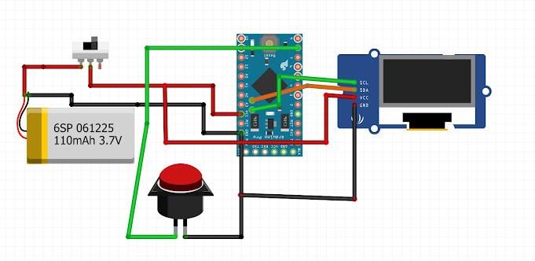  
  
Buton:  
  
+: 8  
-: GND  
  
LCD Ekran:  
  
SCL: A5  
SDA: A4  
VCC: 5V  
GND: GND  
  
Pil:  
  
+: Switch (Farketmez)  
-: GND  
  
Switch:  
  
(Farketmez)